**Parallel Graph Coloring Using MPI**

**1. Introduction**  
Graph coloring is a fundamental problem in graph theory, having several applications in many fields, like scheduling, register allocation in compilers, and frequency assignment in wireless networks. The problem can be defined as giving colors to nodes in a graph such that no two adjacent nodes will have the same color. Since graphs are very large in nature, sequential solutions for graph coloring are computationally expensive. Parallel graph coloring allows for distributed processing such that different parts of the graph may be processed by a separate process. This leverages faster computation times and scalability for big data. This report describes the implementation and analysis of a parallel graph coloring algorithm using the Message Passing Interface framework. It specifically translates the algorithm from Gebremedhin and Manne (2000) [1] into MPI code while exploring and evaluating various improvements to the original algorithm to enhance performance and scalability.

**2. Background**

Graph coloring is a very fundamental concept in graph theory with numerous applications in real-life situations, including scheduling. For instance, in scheduling, graph coloring can be applied to assign time slots for tasks or exams such that no overlapping tasks happen at the same time and thus avoid conflicts. Graph coloring has been widely used in telecommunications, especially in wireless networks, to manage frequency assignments such that neighboring transmitters avoid interference due to operating on the same frequency. In compiler domains, graph coloring is employed to efficiently perform register allocation for variables using a limited number of CPU registers during program execution.

Graph coloring is an NP-hard problem, meaning there is no known algorithm that will efficiently solve the problem for every possible input. However, many heuristic algorithms and approximation algorithms have been proposed to explore near-optimal solutions in realistic time. As a representative example, consider the Recursive Largest First (RLF) algorithm [2], which constructs a color class through successive selections of a maximal independent set of vertices. While it does not always produce an optimum solution, for certain classes of graphs, it is highly effective.

Another approach [3] involves the use of graph neural networks (GNNs) inspired by principles from statistical physics. These GNNs frame graph coloring as a multi-class node classification problem and utilize unsupervised training strategies based on models like the Potts model. This method has shown a lot of promise in providing scalable solutions to large graph instances.

These works further indicate that research into overcoming the computational challenge posed by NP-hard problems such as graph coloring is continuous, with efforts toward the realization of algorithms which can solve them efficiently and practically in realistic situations.

**3. Some of The Existing Methods for Solving the Problem**

**Graph Coloring Approaches**

Graph coloring is a technique in which each node of a graph is assigned a color such that no two adjacent nodes share the same color. This problem is fundamental in various applications such as job scheduling, register allocation, and parallel processing. Traditional algorithms for graph coloring, such as the greedy approach, are efficient for small to medium-sized graphs but these methods become inefficient for large-scale graphs due to their sequential nature.

**Gebremedhin and Manne’s Parallel Algorithms**

A proposal by Assefaw Hadish Gebremedhin and Fredrik Manne (2000) is presented for solving a graph coloring problem in a distributed memory environment. Their approach targeting that color conflicts are minimized as much as possible to improve the result of processing of large, extended graphs among multiple processors. The key features of these algorithms include the following:

1. **Task Distribution**: The graph is decomposed into smaller subgraphs, which are distributed across different processors. This allows for parallel processing, reducing the overall time complexity of the algorithm.
2. **Conflict Reduction**: A key challenge in parallel graph coloring is managing color conflicts between adjacent nodes processed by different processors. This issue is through message passing (MPI), which ensures that the state of nodes is consistently maintained across all processors, thus minimizing conflicts.
3. **Scalability**: The algorithm is designed to scale effectively, enabling it to handle large and complex graphs in distributed systems. It balances the workload of multiple processors, ensuring efficient graph coloring even as the graph size increases.

**Parallel Graph Coloring Algorithms for Distributed GPU Environments [4]**  
This paper introduces hybrid MPI+GPU parallel graph coloring for distributed systems with a focus on performance at large scale for graph coloring. The authors extend the existing distributed memory graph coloring algorithms by introducing GPU acceleration and make it further scalable and efficient. Their approach achieved notable success in handling graphs with over 76 billion edges, thus demonstrating the potential of MPI+GPU algorithms in distributed environments.

**High-performance and balanced parallel graph coloring on multicore platforms [5]**  
Giannoula et al. present ColorTM, a high-performance graph coloring algorithm designed for modern multicore platforms. The paper highlights the use of Hardware Transactional Memory (HTM) to minimize synchronization and data access costs, proposing an eager conflict detection and resolution strategy. Furthermore, they introduce BalColorTM, an extension of ColorTM that ensures balanced color classes, aiming to reduce load imbalance and improve resource utilization. Their algorithms significantly outperform prior state-of-the-art methods in both performance and color balancing.

**4. Test Environment**

The test environment used for this project is the HP Victus 16-R1021NT notebook using Windows 11; it uses the Intel Core i7-14700HX processor. Being among the high-performance processors of Intel's 14th generation of the Raptor Lake series, launched in 2024, the processor integrates great computational capability with efficiency, therefore very suitable for heavy tasks such as parallel graph processing.

The i7-14700HX is based on a hybrid architecture, with 20 cores and a total of 28 threads: 8 Performance-cores (P-cores) and 12 Efficient-cores (E-cores). For P-cores, the base is 2.1 GHz, turbo boosting to 5.5 GHz, while E-cores span between 1.5 GHz and 3.9 GHz. Such a design should allow it to handle multitasking efficiently, do computations quicker, and raise the bar regarding performance in those workloads where several things could be processed at once.  
It is designed around Intel's 10nm advanced process technology: Intel 7, which runs on 33 MB of Intel Smart Cache. Additionally, it provides a maximum memory support of 192 GB DDR5 up to 5600 MT/s. A plus for dependability comes through in the added functionality of integrated Intel UHD Graphics and an efficiently balanced thermal design power of 55 W TDP and 157 W turbo.

**5. Data**

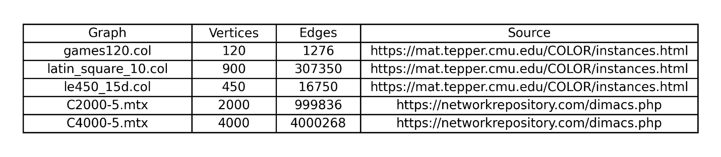The data set for this study comprises five different graphs selected to evaluate the performance and scalability of the parallel graph coloring algorithm. These graphs vary significantly in size and edge density, representing diverse challenges for the algorithm.

The graphs were sourced from reputable online repositories such as the Network Data Repository. The first three graphs [6] (games120.col, latin_square_10.col, and le450_15d.col) are classic benchmarks used in graph coloring research, each featuring varying vertex counts and edge densities. The last two graphs [7] (MatrixMarket1 and MatrixMarket2) were derived from the DIMACS challenge datasets and represent larger, denser structures suitable for testing scalability and parallel performance.

These datasets provide a robust basis for analyzing the algorithm's ability to handle different graph topologies and scales effectively.

**6. Algorithms**

In this section, I present the algorithms developed for solving the parallel graph coloring problem. These include a sequential algorithm, multiple versions of Algorithm 1 and Algorithm 2 from the paper and a new Algorithm 3, each derived from different strategies and approaches to improve efficiency and performance.

**Sequential Algorithm**

Sequential algorithm that I developed is based on Culberson’s Iterated Greedy (IG) [8] coloring heuristic. IG relies on the concept that coloring can be improved by reordering the vertices in a specific way before applying a greedy coloring algorithm. Specifically, the algorithm uses a technique known as *reverse color class ordering*.

In the context of IG, the reverse color class ordering is an ordering of vertices that groups the vertices of the same color class consecutively. This ordering helps reduce the number of colors used by the greedy coloring algorithm. The key insight here is that if the vertices of a graph are reordered so that those belonging to the same color class are grouped together, and the color classes with higher numbers are processed first, applying the First Fit (FF) algorithm will either maintain or reduce the total number of colors required for coloring the graph. This approach enhances the efficiency of sequential coloring by leveraging the structure of the previous coloring and minimizing color conflicts.

After the initial greedy coloring step, the algorithm enters an iterative improvement phase with a maximum limit of 200 iterations. During each iteration, the vertices are reordered using the reverse color class ordering technique, where color classes are processed starting from the highest-numbered class. This reordering is followed by reapplying the First Fit (FF) algorithm to attempt to reduce the total number of colors used.

To optimize performance, the algorithm employs an early stopping mechanism. If the number of colors used does not decrease for five consecutive iterations, the improvement phase is terminated early, avoiding unnecessary computations. This strategy ensures efficiency while still striving to minimize the total number of colors required. The results obtained from experiments on five different graph datasets demonstrate that, thanks to early stopping, the algorithm completed its execution without reaching the maximum of 50 iterations,

The combination of the reverse color class ordering and early stopping helps balance computational effort with the quality of the resulting coloring, making this approach both practical and effective for sequential graph coloring.

**Algorithm 1 Block Partition-Based Coloring**  
This algorithm introduces a parallel graph coloring strategy divided into three main phases. In the first phase, the graph's vertex set V is divided into p equal-sized blocks (V1,V2,…,VP​), with each block assigned to a separate processor. The vertices within each block are then colored in parallel using a greedy approach. At each step, synchronization barriers ensure that all processors progress simultaneously. However, this phase may result in “pseudo-coloring" because two adjacent vertices handled by different processors can be assigned the same color.

The second phase involves conflict detection, where each processor checks whether the coloring is valid for the vertices in its block by comparing the colors of vertices and their neighbors that were processed in the same step. Conflicting vertices are identified, and their details are stored in a table. In the final phase, these conflicting vertices are sequentially recolored to resolve all conflicts, ensuring the graph is properly colored. This hybrid approach balances parallel efficiency and correctness, leveraging parallelism in the initial coloring and conflict detection phases while addressing conflicts sequentially for accuracy.

I implemented this algorithm in three different variations, each exploring a unique approach to improve or adapt the original strategy:

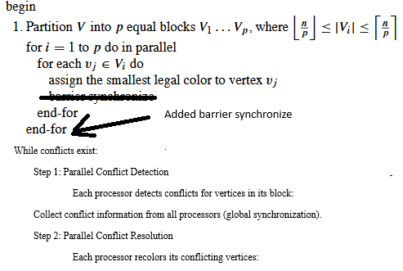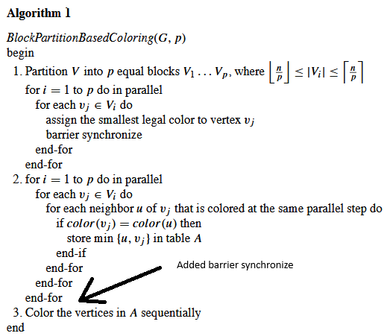

Figure 1.1 Algorithm 1

Figure 1.2 Algorithm 1 Asynchronous

**Algorithm 1 - Basic**

Algorithm 1 Basic, depicted in **Figure 1.1**, serves as the simplest implementation of the graph coloring algorithm. It utilizes fundamental MPI functions like MPI_GATHER and MPI_BARRIER for inter-process communication and synchronization. In this approach, the graph is divided into equal parts, and each process performs greedy coloring in parallel, followed by a global synchronization step. Conflicts are resolved sequentially after this phase, which can lead to inefficiencies due to the lack of advanced parallelism. This algorithm provides a straightforward and foundational method for comparison with more optimized approaches.

**Algorithm 1 - Half Asynchronous**

Algorithm 1 Half Asynchronous, based on **Figure 1.2**, improves upon the basic version by leveraging more advanced MPI functions such as MPI_Allgather and MPI_Allreduce. These functions enable efficient global data sharing and conflict detection in parallel, significantly reducing communication overhead. After the initial parallel coloring phase, the algorithm iteratively detects and resolves conflicts in parallel, alternating between resolving "small" (lower vertex ID) and "large" (higher vertex ID) conflicts in each iteration. This alternation is targeted to help balance the computational load across processes and enhances scalability, making this version more suitable for larger and more complex graphs.

**Algorithm 1 - Asynchronous**

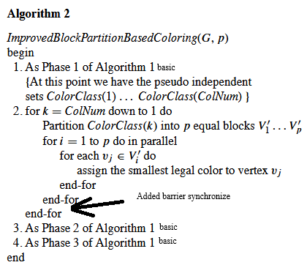Algorithm 1 Asynchronous extends the Half Asynchronous approach by introducing non-blocking MPI communication functions, such as MPI_Isend and MPI_Irecv, to overlap computation and communication. This version further optimizes parallelism by minimizing idle times and reducing synchronization delays between processes. Like the Half Asynchronous algorithm, it alternates between resolving "small" and "large" conflicts during the iterative conflict resolution phase to even distribute the workload.

Figure 2.1 Algorithm 2

**Algorithm 2 - Basic**

Figure 2.2 Algorithm 2 Asynchronous

Algorithm 2 Basic, shown in **Figure 2.1**, provides a foundational implementation of the graph coloring algorithm using basic MPI functions like MPI_GATHER and MPI_BARRIER. Like Algorithm 1 Basic, this version divides the graph into parts and performs greedy coloring in parallel. However, its conflict detection and resolution are simplified and handled sequentially after synchronization, limiting its performance on larger datasets. This algorithm serves as a straightforward starting point for understanding the enhancements made in subsequent versions.

**Algorithm 2 - Parallel**

Algorithm 2 Parallel builds upon Algorithm 2 Basic, introducing an improvement inspired by Algorithm 1 Half Asynchronous. Specifically, it adopts the advanced conflict detection and resolution methods from Algorithm 1 Half Asynchronous, where conflicts are resolved in parallel. This allows for more efficient handling of coloring conflicts while retaining the overall structure of Algorithm 2 Basic. As a result, this version strikes a balance between simplicity and improved scalability compared to the basic approach.

**Algorithm 2 - Half Asynchronous**

Algorithm 2 Half Asynchronous, based on Figure 2.2, introduces advanced communication and parallelism strategies similar to those in Algorithm 1 Half Asynchronous. It uses MPI_Allgather and MPI_Allreduce for efficient global conflict detection and parallel conflict resolution. During each iteration, the algorithm alternates between resolving "small" (lower vertex ID) and "large" (higher vertex ID) conflicts, ensuring balanced workload distribution. Additionally, the reverse color ordering in the second phase is implemented differently from what is shown in Figure 2.2. Here, processes handle only their assigned subgraph and perform the reverse ordering within that area, checking conflicts in reverse order only once. This localized reverse-order adjustment improves efficiency by limiting the scope of conflict checks to relevant areas, making the algorithm more scalable for larger graphs.

**Algorithm 2 - Asynchronous**

Algorithm 2 Asynchronous also relies on **Figure 2.2** and extends the Half Asynchronous version by incorporating non-blocking MPI operations, such as MPI_Isend and MPI_Irecv. These asynchronous methods overlap computation with communication, reducing idle times and improving performance. Like Algorithm 2 Half Asynchronous, it alternates between resolving "small" and "large" conflicts during iterative conflict resolution.

**Algorithm 3**

Algorithm 3 closely resembles Algorithm 2 Asynchronous, with one key difference in how conflicts are resolved during each iteration. Instead of alternating between resolving "small" and "large" conflicts, the data distribution shifts as though the ranks of the processes were rotated forward by one in each iteration. This modification ensures that the workload distribution varies across iterations, potentially leading to better load balancing and improved parallel performance for certain types of graphs.

**7. Results and Discussion**

The experimental results indicate that all the proposed algorithms, when executed with one process, were faster than the sequential algorithm. This speed advantage arises because the sequential algorithm employs an epoch mechanism, which introduces additional computational overhead.

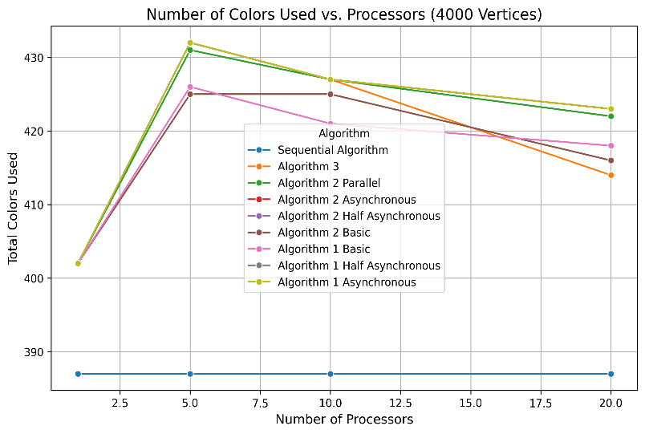Despite their speed, the parallel algorithms consistently used approximately 5% more colors than the sequential algorithm when using only 1 processor. This discrepancy stems from differences in the coloring strategies between the parallel and sequential implementations, despite sequential algorithm employing extra work for reducing color number with epoch mechanism I think the difference is not that big. For more than one processor the difference in general is bigger than %10. When I increased the number of processes to 20, it dropped to about 10%. It is also clearly seen in Figure 3 that algorithm 2-based ones, except algorithm 2 Parallel, use less color than algorithm 1-based ones.

Interestingly, as the number of processes increased beyond five, the total number of colors used by the parallel algorithms decreased. This behavior can be attributed to enhanced parallel conflict resolution, where dividing the graph among more processes reduces the likelihood of conflicts in specific subgraphs. The localized nature of conflict detection and resolution in the parallel algorithms allows for more efficient use of colors, especially as the graph is divided into finer partitions.

Figure 3 Number of Colors vs Number of Processor

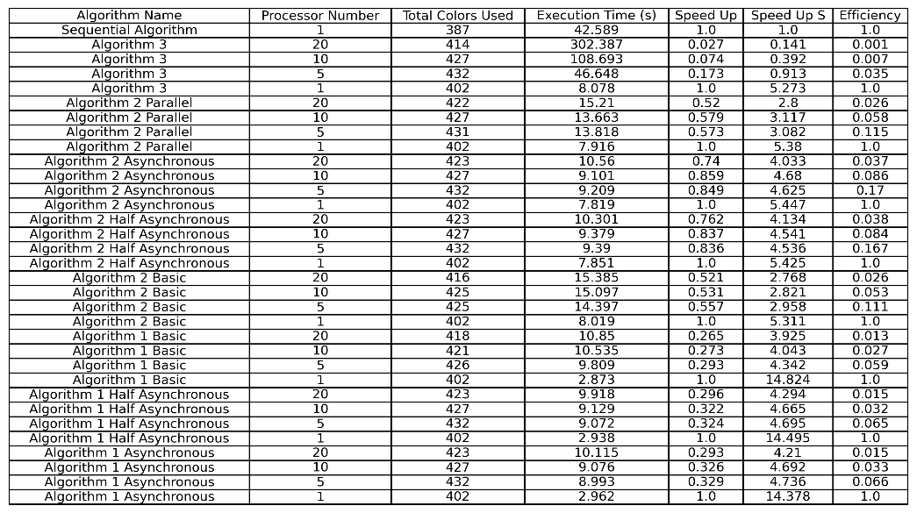However, it is worth noting that all the parallel algorithms exhibited their fastest performance when executed with only one process. This counterintuitive result is likely due to the experimental setup, as the tests were conducted on a Windows-based system. The Windows operating system may introduce additional overhead in managing inter-process communication (MPI) compared to a Linux-based system, which is generally more optimized for high-performance computing tasks

Figure 4 Example Results for C4000-5

All graphs and results can be found in GitHub as Python code, txt file or image [9]. For figure 4 Speed Up S Means Speed Up Compared to Sequential.

Figures 5, 6, and 7 provide insights into the performance of the algorithms. Except for Algorithm 3, all parallel algorithms outperformed the Sequential Algorithm in terms of execution speed. Among these, the Half Asynchronous and Asynchronous versions emerged as the fastest, showcasing the benefits of reduced synchronization overhead and improved parallelism in their designs.

Figure 5 Scalability Graph

However, as previously mentioned, increasing the number of processes from 1 to 5 resulted in a significant speed loss across all algorithms. Beyond the 5 processes, there were no substantial speed gains or losses, except for Algorithm 3. This algorithm exhibited substantial performance degradation as the number of processes increased.

Figure 6 Scalability Graph against Sequential Algorithm

The observed trends likely stem from the test environment, particularly the Windows operating system and its implementation of the MPI library. It appears that Windows—or possibly my computer—fails to effectively utilize processors beyond the first one. These inefficiencies in inter-process communication are more pronounced on Windows compared to Linux, which is generally better optimized for parallel high-performance tasks.

Figure 7 Efficiency Plot

Regarding Algorithm 3, I do not believe the modifications introduced in its design are significant enough to explain its unique behavior. Instead, the performance issues are likely due to system-related factors rather than algorithmic design.

It is important to note that these conclusions are based on experiments conducted on a graph named C4000-5 ensuring consistency across all measurements. I used C4000-5 because it is the biggest graph in my project.

**8. Conclusion**

In this study, I think I successfully implemented and analyzed parallel graph coloring algorithms using MPI, based on the work of Gebremedhin and Manne (2000) [1]. The primary goal was to translate their algorithm into an MPI-based parallel implementation, explore variations of the algorithm, and evaluate their performance. My findings highlight the trade-offs between execution speed, parallel efficiency, and the number of colors used. The experimental results showed that all parallel algorithms, except Algorithm 3, were faster than the sequential algorithm when executed with a single process, primarily due to the absence of the epoch mechanism. However, this speed advantage came at the cost of slightly higher color usage.

The analysis revealed key insights into the behavior of algorithms as the number of processes increased in the test environment I used. While all parallel algorithms initially experienced significant speed losses when scaling from 1 to 5 processes, their performance stabilized beyond 5 processes. Most notably, the Half Asynchronous and Asynchronous algorithms consistently outperformed the others in terms of execution speed. Algorithm 3, however, exhibited significant performance degradation as the number of processes increased, likely due to inefficiencies.

In conclusion, this study demonstrates the feasibility and challenges of implementing parallel graph coloring algorithms using MPI. While the parallel algorithms achieved notable speedups compared to the sequential version likely due to not having epoch mechanism, their performance was probably limited by the experimental setup, particularly the inefficiencies of the MPI library on Windows. Future work could focus on optimizing the implementation for Linux-based systems to see if the real reason for performance degradation when using more than one process is because of the test environment or exploring alternative parallel computing frameworks. Additionally, further investigation into the performance anomalies of Algorithm 3 and the scalability of these algorithms on larger and more complex graphs would provide deeper insights into their potential for real-world applications.

**References**

[1] Gebremedhin, A. H., & Manne, F. (2000). Scalable parallel graph coloring algorithms. *Concurrency: Practice and Experience*, *12*(12), 1131–1146. <https://doi.org/10.1002/1096-9128(200010)12:12%3C1131::aid-cpe528%3E3.0.co;2-2>

[2] Leighton, F. T. (1979). A graph coloring algorithm for large scheduling problems. *Journal of Research of the National Bureau of Standards*, *84*(6), 489. https://doi.org/10.6028/jres.084.024

‌[3] Schuetz, M. J. A., Brubaker, J. K., Zhu, Z., & Katzgraber, H. G. (2022). Graph coloring with physics-inspired graph neural networks. *Physical Review Research*, *4*(4). https://doi.org/10.1103/physrevresearch.4.043131

‌[4] Bogle, I., Slota, G. M., Boman, E. G., Devine, K. D., & Rajamanickam, S. (2022). Parallel graph coloring algorithms for distributed GPU environments. *Parallel Computing*, *110*, 102896. https://doi.org/10.1016/j.parco.2022.102896

[5] Giannoula, C., Peppas, A., Goumas, G., & Koziris, N. (2022). High-performance and balanced parallel graph coloring on multicore platforms. *The Journal of Supercomputing*, *79*(6), 6373–6421. <https://doi.org/10.1007/s11227-022-04894-6>

[6] *Graph Coloring Instances*. (n.d.). Mat.tepper.cmu.edu. https://mat.tepper.cmu.edu/COLOR/instances.html

[7] Network Data Repository. (2015). *DIMACS Networks*. Network Data Repository. https://networkrepository.com/dimacs.php

‌[8] Culberson, J. (1992). *Iterated Greedy Graph Coloring and the Difficulty Landscape*. https://doi.org/10.7939/r3m32nh6q

‌[9] b21945815. (2025). *GitHub - b21945815/METU-MPI-GraphColoringProblem*. GitHub. https://github.com/b21945815/METU-MPI-GraphColoringProblem

‌